MIDTOWNERS SUNSHINE OF THE WEEK ► July 20th, 2007
Birthday of Rtn. Albert Grela on July 24th
Birthday of PP Anand Tuladhar on July 26th
Birthday of Tenzin Choegyal, spouse of Rtn. Lisa on July 22nd
Birthday of Dr. Banu Sharma, spouse of Rtn. Neil on July 23rd
Birthday of Reenchen Ma, spouse of PP William on July 24th
Anniversary of Rtn. Luke and Marianne Sunde on July 20th

SPEAKER OF THE WEEK ► Mr. Pramod Poudel
THEME | Handicraft and Agro Product Export
Mr. Pramod Poudel currently manages Kathmandu Gallery, focusing on the export of Nepali arts, craft and agro products. He holds an M.A. in from Central Department of Economics, TU. He has extensive prior experience in carrying out economic, budgetary, and policy researches.

UPCOMING SPEAKERS ► PREVIEW
DATE | SPEAKER | THEME
July 27th | Ms. Caroline Jacoby  Johns Hopkins Center for Communications Program | Health Education through Radio and TV
Aug 3rd | Ms. Trishna Gurung  Communications and Marketing Manager, WWF Nepal | Global Climate Change
Aug 10th | Mr. Rajeev Adhikari  Sr. Consultant, Total Management Service | Donor driven Development

THE MID-TOWN CLUB ► NEWS
INSTALLATION OF NEW BOARD
We had a short and sweet installation ceremony for the new board headed by our incoming President Walter Diller. The program was attended by AG Purna Man Shakya. Outgoing President (now IPP) CK Golchha gave a report on the club’s achievements last year and thanked the members for their assistance. PP Ambica praised IPP CK for leading the club during a tumultuous year for him personally. President Walter talked on his plans to maintain the high standards of our club and strengthening our membership.
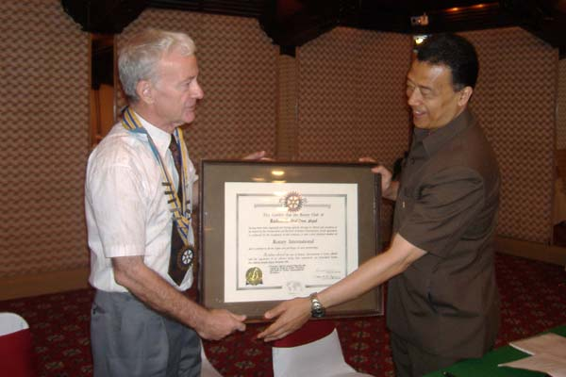 | 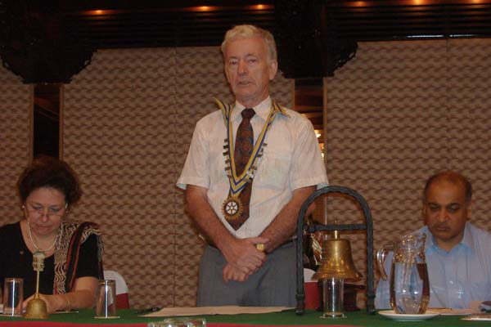
CP Roop handing over Charter Certificate | President Walter giving his inaugural speech
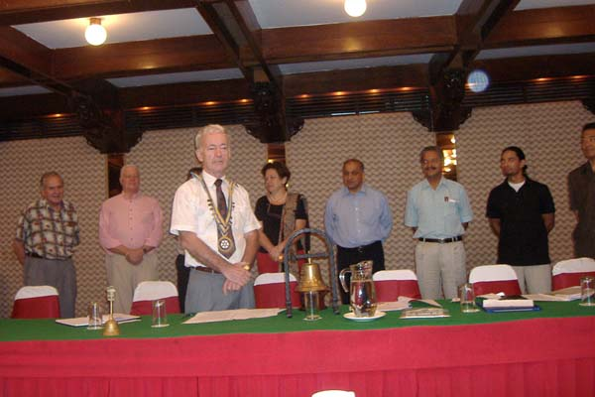 | 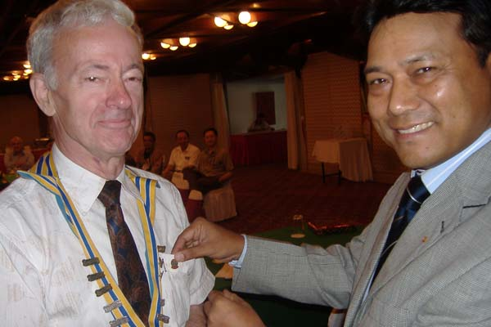
President Walter presenting the new Board | AG Purna Man Shakya pinning President Walter

Mid-Town ROTARACT Report
On July 19th, the Rotaracts of Mid-Town visited Moti Binyak Primary school in Dholahiti and did the following:
- Mid Day meal of bread with jam and eggs with children
- Donate 50 plates and spoons /dustbins
- Provided de worming tablets to the children in concern of their health
- Provided plenty of trees and plants which were personally planted by them in concern of the environment
- Educated the children on the food items that they had for the meal

THE ROTARY INTERNATIONAL ► NEWS
Rotary ranked among top five NGOs for corporate partnerships
The Financial Times has ranked Rotary International one of the top five nongovernmental organizations (NGOs) for corporate partnerships. In the newspaper’s special supplement, Corporate Citizenship and Philanthropy, Rotary came in fifth in the global rankings of 34 finalists.
Published in conjunction with the UN Global Compact Leaders Summit held 5-6 July in Geneva, the supplement reached some 1.4 million senior business executives, industry and government leaders, and private/institutional investors across 140 countries.
The summit, which was chaired by UN Secretary-General Ban Ki-moon, featured an international roster of business leaders, government ministers, and heads of civil society and focused on such key challenges to building future markets as human rights and climate change. RI Director Bernard Rosen of Belgium represented RI President Wilfrid J. Wilkinson at the event.
UN Global Compact and Dalberg Global Development Advisors, who developed the report in preparation for the summit, surveyed 20,000 companies worldwide, identifying 550 NGOs, UN agencies, foundations, and other organizations with which companies had partnered, and profiled 85 of those based on company ratings.
Organizations that ranked higher than RI showcased long-standing partnerships with corporations. Because RI's global partnerships include only UN agencies and other nonprofit organizations - and only Rotary clubs and districts have partnered with corporations to date – the organization’s ranking should be considered exemplary. RI has a long and distinguished history of collaborating with other organizations in the name of humanitarian service.
From Rotary International News, July 11, 2007

Did you know?
The Council on Legislation, Rotary's "parliament,' meets every three years to deliberate and act upon all proposed enactments and resolutions submitted by clubs, district conferences, the General Council or the Conference of Rotary International in Great Britain and Ireland, or the Rotary International Board. The council itself also makes proposals. While the Board of Directors sets policies for Rotary International, the Council on Legislation allows Rotary clubs to have their say in the governance of the association.
The council is composed of more than 500 representatives from every part of the Rotary world. Voting members include one elected representative of the clubs of each Rotary district. Non-voting members include the chairman and vice chairman of the council, and others, including the RI president and members of the RI Board and past RI presidents.
Editor: Rabi Karmacharya, Club Service Director email: rabikarma@gmailcom

